Dialogs In Original Sin
Contents
Speakers and Voices 1
Creating and assigning speakers and voices 2
Creation 2
Creating Speakers 4
Creating Speaker Groups 4
Creating Voices 5
Saving your changes 7
Assigning speakers 7
Dialogs 8
Interactive Dialogs 8
Automated Dialogs 8
Multiplayer dialogs 8
Dialog templates 8
Party Dialogs 11
Dual Dialogs 12

Speakers and Voices
The first thing you should do before creating dialogs for your characters is assigning the speaker and the voice for your characters.
Every character has a speaker property. This property tells the game what voice a character has and is used by dialogs to display who's saying what. A speaker can be shared between different characters. In general important characters should have a unique speaker, while generic citizens could share a speaker with others. When you create a speaker, it should have a unique name and be clear in a way that it leaves no confusion to how that speaker is used.
Every speaker also has a voice. This decides what sound files are used when dialog needs to be spoken by the character. A voice can be shared between multiple speakers or be unique to a speaker. The same rule applies here as with speakers: unique/ important speakers will have a unique voice; others will share their voice with multiple speakers.

Creating and assigning speakers and voices

Creation
Click the Speaker Manager icon in the Glasses editor
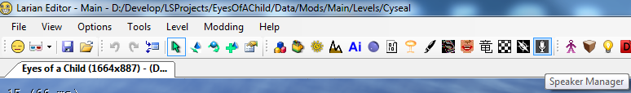
This will open the Speaker Manager window:
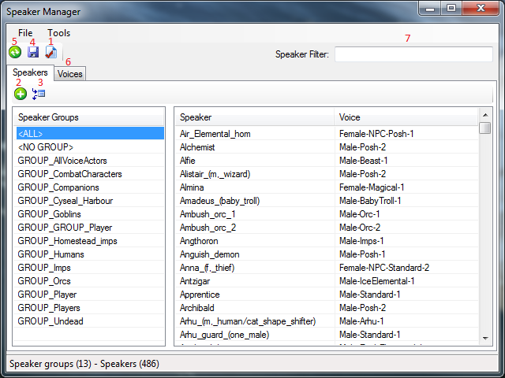
Figure 1: Speaker Manager
Before you start creating your speakers and voices, make sure you have the speaker file (\LSProjects\EyesOfAChild\Data\Mods\Main\Story\Voice\Speakers.lsb) checked out. You can do this by pressing the 1 button.
You add a speaker by pressing the 2 button. This will pop up the following menu:
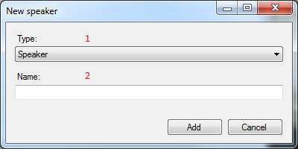
Figure 2: Speaker Creation
You fill in a unique, clear name in the textfield 2.
The dropdown list in 1 allows you to select what you want to create. A speaker group or a speaker.

Creating Speakers
Fill in a unique, descriptive name in the textfield 2. You can find back your created speaker by typing the name in the filter field 7. Make sure you have the <ALL> group selected before you do this.
Right clicking a speaker will give you a context menu:
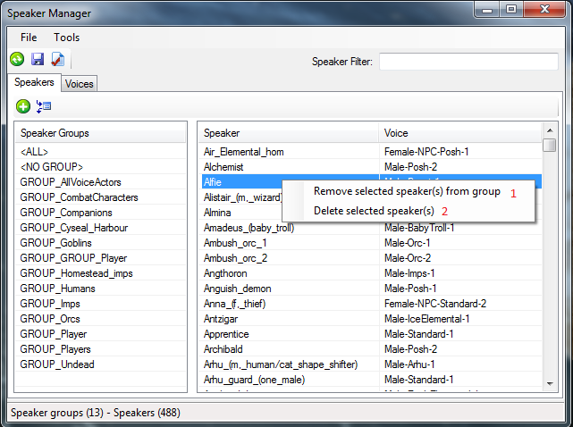
Figure 3: Speaker Context Menu
Use 1 to remove a speaker from a Speaker Group (see section below). Use 2 to remove the speaker from the list of Speakers.

Creating Speaker Groups
Speaker groups allow you to group speakers that logically belong together. Typically these would be based on race or faction of characters. As with speakers, Groups should have a unique and clear name. The convention is to let the group names start with "GROUP_". When you click "Add" when creating a group a window to assign speakers will pop up. Every group needs some speakers assigned to it. You can't create an empty group.
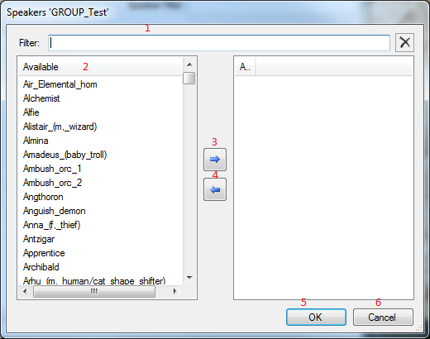
Figure 4: Editing a group
Use the filter field 1 to quickly find speakers in the list of speakers (2 ). Use the button 3 to add a speaker to the group you're creating. Use the button 4 to remove a speaker from the group. Hit OK (5) to create the group or Cancel (6) to cancel the creation of the group.
Use button Figure 1 : 3 to add or remove Speakers from an existing Speaker Group. A menu like the one in Figure 4 will pop up.

Creating Voices
Select the Voices tab in figure 1:6. You'll see the following screen:
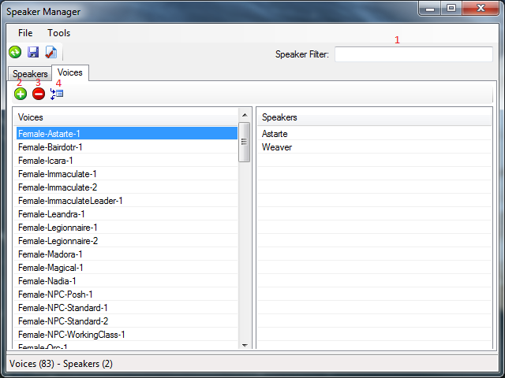
Figure 5: Voices menu
The textfield figure 5: 1 allows you to filter the list of voices. Hit figure5: 2 to create a new voice. The following menu will pop up:
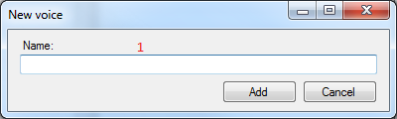
Figure 6:Creating a voice
In the textfield 1 you can enter a name for the voice. This should a unique and descriptive name. When you hit "add" a menu will pop up, similar to Figure 4. Here you add speakers to your voice. A voice needs to have Speakers assigned.
Use button figure 5: 3 to remove a voice. Use button figure5: 4 to add or remove speakers for a certain voice.

Saving your changes
When you're done creating Speaker or Voices, make sure you save your changes. You can do this by hitting the button figure1: 4.

Assigning speakers
To assign a speaker you need to have your character selected in the editor. You then open the property page with ctrl-B and scroll down to the Speaker field in the properties page. See figure 7.
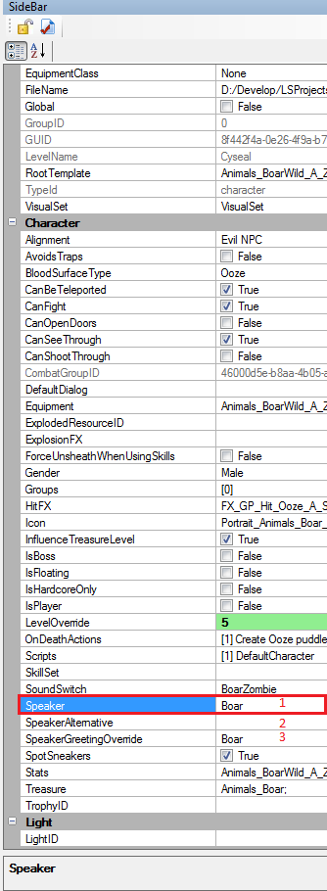
Figure 7: Character properties pane

Clicking the dropdown list 1 will present you with a list of speakers. Select the speaker you want from the list.
You can assign a second Speaker to a character in 2. You probably won't have to do this. This option is there to have characters be able to say lines that weren't recorded for their main Speaker. In 3 you can assign a different Speaker to use for playing the Greeting in the character's dialog. Again, you probably won't have to do this.

Dialogs
Dialogs in Divinity Original Sin (DOS) have a set naming scheme. They always start with a 3 letter abbreviation for the area they belong to. For example "CYS_" for Cyseal.
There's 2 types of dialogs in DOS:
Interactive dialogs and Automated dialogs.

Interactive Dialogs
Interactive dialogs are dialogs that have a player character actively involved in. That means the player needs to select answers and click continue to progress in the dialog. These dialogs block players from moving around. These dialogs need to be started from Osiris. Osiris does a lot of tracking to keep everything working correctly with interactive dialogs. See the "Useful Osiris systems" for more information on how to start interactive dialogs.

Automated Dialogs
Automated dialogs are dialogs that have no player characters involved in. These are dialogs between NPC characters or just things a single character will say ingame as part of his behaviour. These dialogs will show up as text above the heads of NPCs. They do not block players from moving around. Since they don't interrupt gameplay these can be started from Character scripts or directly from Osiris using the DialogStart<X>SpeakerDialog function calls.
Automated dialogs need an additional "_AD_" prefix in their name. For example: CYS_AD_FishVendor.

Multiplayer dialogs
In Divinity Original Sin (DOS) it's possible to have Interactive Dialogs with more than 1 player. We call these Multiplayer Dialogs. We define 2 types of multiplayer dialogs: party dialogs and dual dialogs. If you use the main game as a dependency you'll have access to a couple of procedures and scripting logic to handle these 2 cases.

Dialog templates
To help you setup these multiplayer dialogs, we've provided a couple of dialog template files. These are files that contain the basic structure of multiplayer dialogs. You can import these files from the keyword editor so that all you need to do is fill in the text and any global or characters flags you want.
Here are the steps to import a dialog template in the editor:
1. Go to the "Import Nodes" menu item in the "Dialog" menu
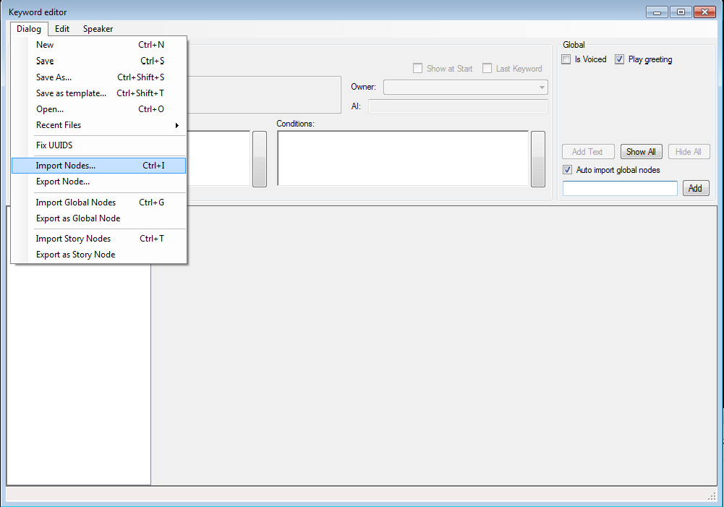
Figure 8: Import Nodes menu item

2. From the file chooser window, go to 1 and change the type to "Dialog template"
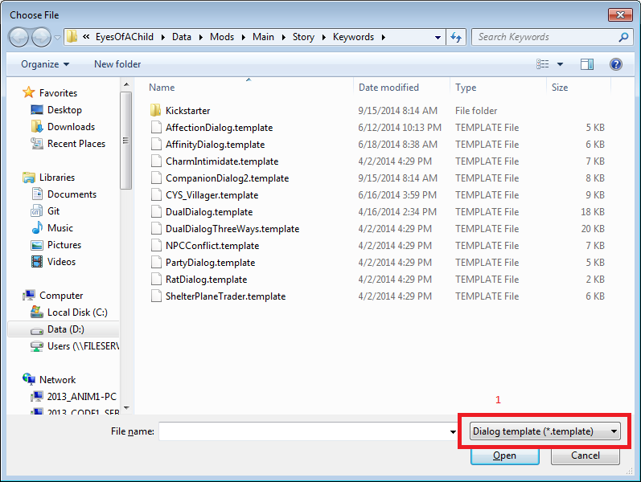
Figure 9: listing dialog templates
3. Select your dialog template you wish to import and select "Open".
4. A choose nodes dialog will pop up. Here you can manually select which nodes you want to import or just tick the checkbox "All" in 1. For the dialog templates in this document you'll select "All".
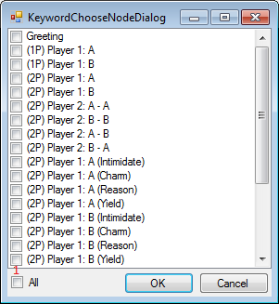
Figure 10: choose nodes

Party Dialogs
Part dialogs are the dialogs where exclamation marks appear over the heads of the players. Typically you get these to reflect over actions the players just performed.
Party dialogs are the easiest to use. You make a dialog like any other, where your first and second speaker will be players. You use the Osiris procedure ProcDefinePartyDialog to trigger the exclamation mark effects and assign the dialogs to the players. When a player in the game clicks on one of the players, the dialog will be started. Cleanup of the effects and removing the dialog after it's been started is all handled by the main campaign scripting.
To help you setup these dialogs a dialog template DualDialog.template is provided. You need to fill in the string in the SetFlag calls in the action parts of the nodes. If you don’t need/or want a flag, just leave it empty.
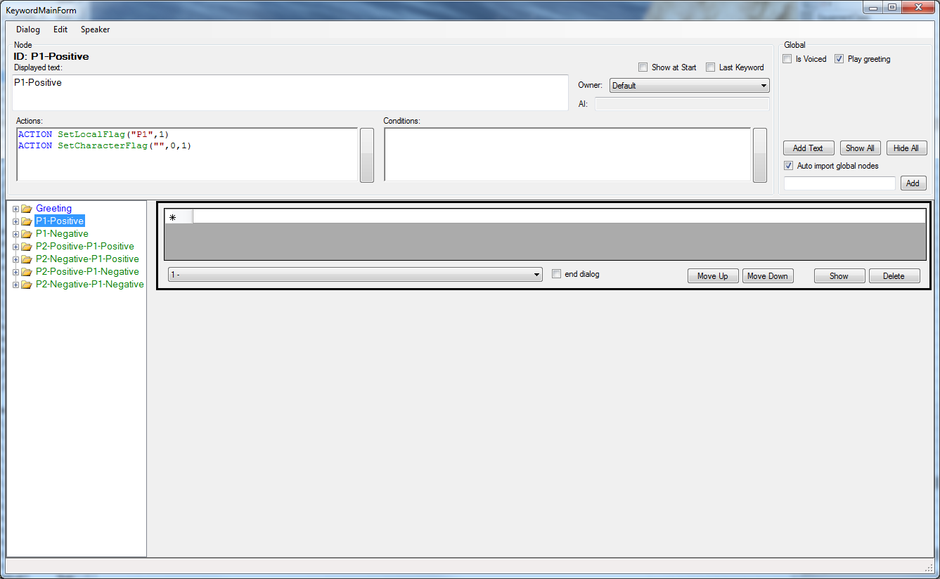
Figure 11: Party Dialog template nodes
Party Dialogs should have "_PD_" as an additional prefix in their name. For example: " CYS_PD_AfterSam".

Dual Dialogs
Dual Dialogs are dialogs that are started from normal dialogs with NPCs. Typically these are used to make a decision (ie. do we accept the NPC’s quest or not?). They contain the Rock Paper Scissors minigame.
Dual dialogs are started from a normal NPC dialog. We use the script action “StartDialog” in the keyword dialog to send an event to Osiris. Osiris then checks how many players need to be in the dialog. If the players are too far from each other or a player in unavailable (dead, in another dialog, etc.) only the player that was in the NPC dialog will be in the dual dialog. The dual dialog itself is just another dialog, where the first and second speaker are players. The second speaker could be empty if Osiris decided that only 1 player will be in it. So the dialog contains 2 flows: one for 1 player and another for 2 players.

To help you setup these dialogs a dialog template PartyDialog.template is provided. You can fill in the event for the SetCharacterFlag in the action parts of the nodes if you want.
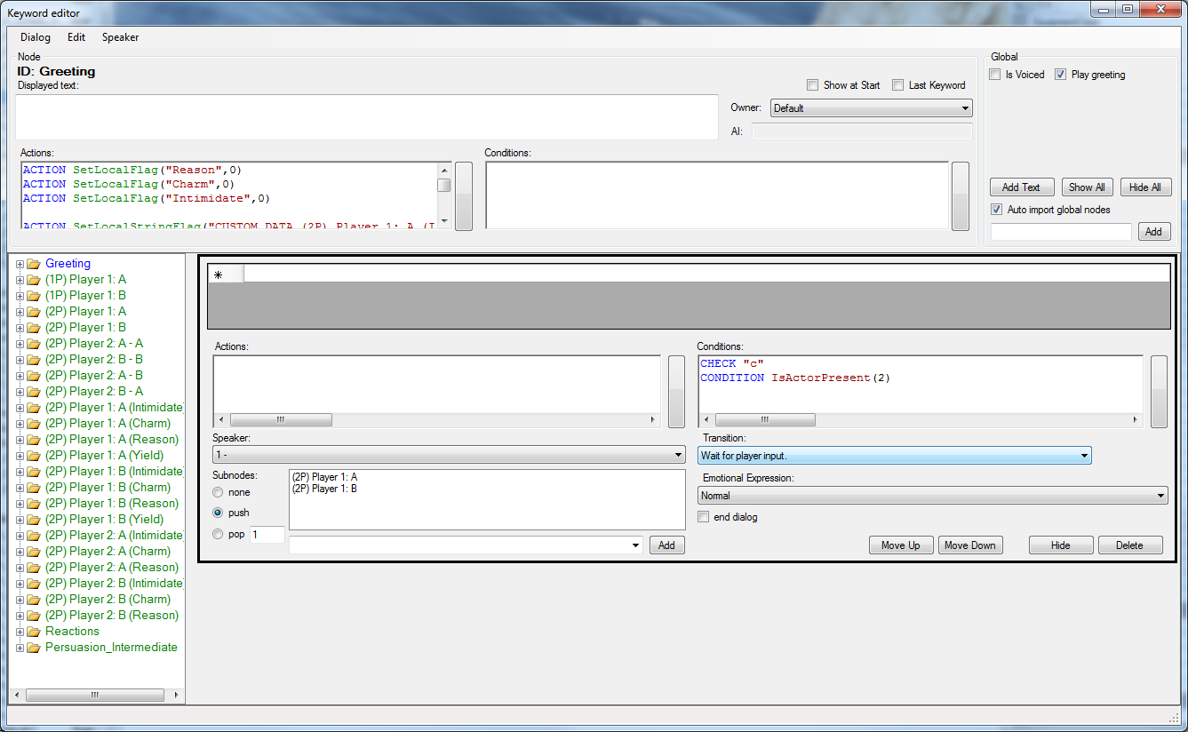
Figure 12: dual dialog template nodes
Dual Dialogs should have "_DD_" as an additional prefix in their name. For example: "CYS_DD_Shell".

Charm - Intimidate - Reason

Definition
Some NPCs will need convincing to do something for you. This convincing is done through a special dialog option. DOS will provide you with 3 options to convince an NPC : either using reason, charm or intimidate. When a dialog option is hit to convince an NPC, you'll be presented with those 3 options. After making your choice the game will launch a Rock, Paper, Scissors minigame. After the minigame the NPC's reaction will be presented.
To setup such a dialog, there's another template provided. Namely CharmIntimidate.template.
In the greeting node of this template you can give bonuses or penalties to one of the 3 options. This is done by modifying the following block of flags:
ACTION SetLocalFlag("Intimidate",0)
ACTION SetLocalFlag("Charm",0)
ACTION SetLocalFlag("Reason",0)

Setting a flag to 1 will give it a boost. Setting it to -1 will give it a penalty.
In the Reactions node you can script your responses depending on a player's choice and if he won the conflict or not.

Multiple Charm Intimidate Reason options
Some dialogs will have more than 1 Charm Intimidate Reason (CIR) option. At the moment dialogs can only support 2.
To add a second CIR to a dialog, import the nodes from the CharmIntimidate template except for the Greeting. In the greeting of your dialog, add the following block of statements before the call to "Set_Persuasion_Flags"! :
ACTION SetLocalFlag("Intimidate2",0)
ACTION SetLocalFlag("Charm2",0)
ACTION SetLocalFlag("Reason2",0)
ACTION SetLocalStringFlag("CUSTOM_DATA_Reason2","Reason2")
ACTION SetLocalStringFlag("CUSTOM_DATA_Charm2","Charm2")
ACTION SetLocalStringFlag("CUSTOM_DATA_Intimidate2","Intimidate2")

You can setup bonuses or penalties for the second CIR by filling in values for the SetLocalFlag statements.
Next, add a "2" to the imported nodes from the template. So you end up with "Reason2", "Charm2", "Intimidate2", "Persuasion_Intermediate2", "Reactions2".
Next, in the "Reason2", "Charm2", "Intimidate2" nodes, change the JumpToNode script call to this:
ACTION JumpToNode("Persuasion_Intermediate2")

Finally, in the "Persuasion_intermediate2" node, in the last TextNode, change the JumpToNode call to this:
ACTION JumpToNode("Reactions2")

For an example, check "HIB_ImmaculateCharmer2.lsx"

